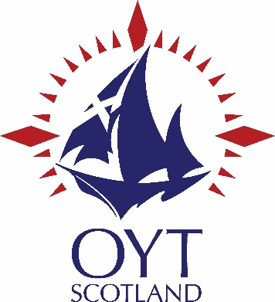

Assisted Berth Scheme
Individual Application Form
& Guidance Notes

Assisted Berth Scheme Individual Application Guidance Notes

The Assisted Berth Scheme (ABS) is a fund raised by OYT Scotland to help young people afford the fees to take part in a youth voyage. The ABS exists to help those young people who are most in need of financial assistance. The ABS is made up of a number of donations and grants from various public and private bodies. This fund is limited and the amount in it changes year on year, so some applications may not be successful. As a guide your application will be considered if you meet one of the following criteria:

- You or your parent(s)/guardian receive low income benefits.
- You or your parent(s)/guardian are not in full time employment.
- You receive free School meals.
- You are looked after by a single parent or guardian.
- You are a student in receipt of financial support.
- You are a carer looking after siblings or a parent/guardian.
- You have additional support needs.

The above list is not exhaustive and all applications will be considered should you feel your circumstances qualify you for a grant.

If you are unsure whether you qualify please contact us on 01475 722 722.

The following guidelines and rules should be followed by all applicants:

When filling out the form please ensure you complete all details including:

- Your name (person sailing), address, date of birth, telephone number and email address.
- Contact name – this could be a parent, guardian, or person making the application on behalf of the young person.
- The voyage details dates and boat name. This is available from our website or from our office.
- The full voyage cost and how much financial assistance you wish to apply for (in £’s). (We are unable to fund the whole cost of the voyage).
- Tell us about yourself, about your circumstances and why you need financial assistance.
- Tell us what you will gain from the voyage. This is your chance to tell us about your interests and what the voyage will mean to you.
- Tell us how you will get the remainder of the voyage fee. This may be a contribution from a parent or guardian or you may be fundraising.

Rules for applicants:

- Applicants must be aged 12-24 years at the time of the voyage.
- All applications must be completed on the ABS application form, signed, dated and posted/scanned to the OYTS office as soon as possible. Applications submitted late or near to the date of departure may not be considered.
- Any applicant under the age of 16 must have the application signed by a parent or guardian.
- The application will be considered by OYT Scotland ABS Committee. Their decision on funding is final.
- All applications will be considered on an equal basis.
- Applicants will be advised of the outcome by phone, email or a letter.
- The amount awarded will be deducted from the applicants berth fee. No money will be sent to the applicant.
- Priority will be given to applicants resident in Scotland.
- Successful applicants are required to complete a report after their voyage so that OYTS can report to ABS funders on how their support is being used.

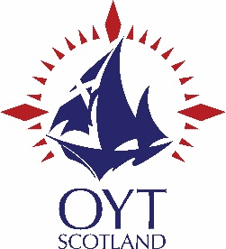
Assisted Berth Scheme Individual Application Form
Please tell us about yourself and why you want to sail with Ocean Youth Trust Scotland.
How much financial assistance do you hope to receive from the ABS Scheme? (See guidance notes)
Voyage Dates:

Email:
Date of Birth:
Telephone:
Contact name (parent/guardian etc.)

Your Name (person sailing)

Total Cost of Voyage:

Address

Please tell us about your circumstances and why you should qualify for a grant?
OYT Scotland’s voyages present many opportunities for personal development. What do you hope will be the key outcomes for you?

Please tick the boxes below that apply to you;

- You or your parent(s)/guardian are not in full time employment.
- You receive free School meals.
- You are looked after by a single parent or guardian.
- You are a student in receipt of financial support.
- You are a carer looking after siblings or a parent/guardian.
- You have additional support needs.

Amount:
Approved:
Date:
For Office Use Only
Signature of Parent or Guardian
(if applicant under 16)
Date:
Name of Parent or Guardian
(if applicant under 16)
Your Signature:
I declare that the information furnished on this form is true and complete to the best of my knowledge and belief.
I agree to provide a short report within 2 weeks of my voyage ending.
What skills do you to gain from the voyage?
OYT Scotland will fund part of the voyage cost. Please tell us how you intend to raise the rest of the cost.

